“Have just documented the procedure for integrating web application with OpenRules Engine. This was one of the articles which i was expecting when i started off with Open Rules - but i couldn't get it. It would be good if you could make this available to all - here i have used RAD as the IDE.”
P.N.Subramanian, pn.subramanian@gmail.com
Feb 9, 2007

Integrating Web Applications with OpenRules Engine using RAD 6.0

Introduction

Business Rules have always been an integral part of web-based applications. There have been efforts to isolate business rules, configuration data from the rest of the code, so that software applications are able to address the factor that is almost a certainty – change.
One of the available tools for business rules management is OpenRules Engine.

This article outlines the integration of OpenRules Engine with existing web applications in IBM Rational Application Developer RAD 6.0.

Pre-requisites

Familiarity with the working of OpenRules Engine and awareness on the creation of rules table. Basic knowledge of working with RAD 6.0.

OpenRules Engine

The OpenRules Engine is used to create decision support (if-then-else scenarios) systems that can be used to create, execute and maintain business rules in applications. The decision support systems are created using MS Excel as the rules editor i.e. the set of rules, decisions or methods are placed in MS Excel and these get invoked at run-time from within Java code. The rule implementation details are created by the use of Java snippets directly in MS Excel sheets. For more information on OpenRules Engine, please refer – www.openrules.com.

Usage

The step-by-step usage of OpenRules Engine using RAD 6.0 is illustrated below.

- Create a workspace c:\TestRAD\workspace

- Switch to Java perspective

- Create a project testOpenRules

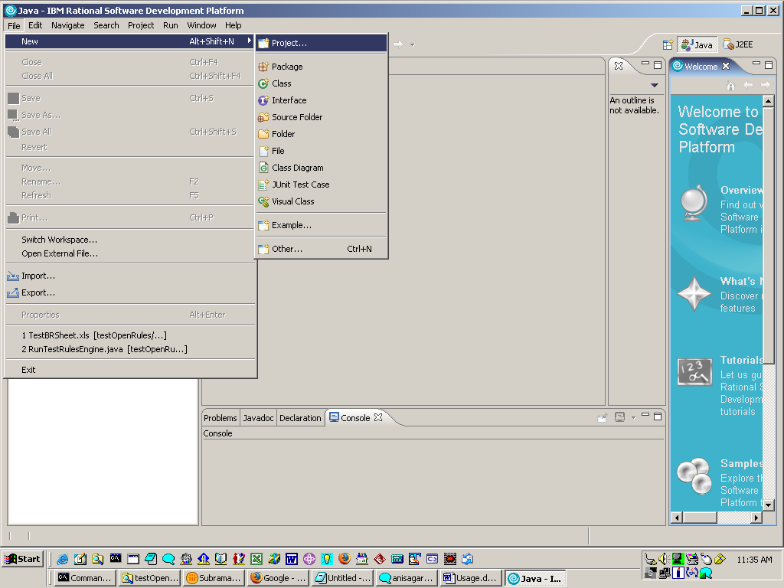

- Specify the Project Name and say Next

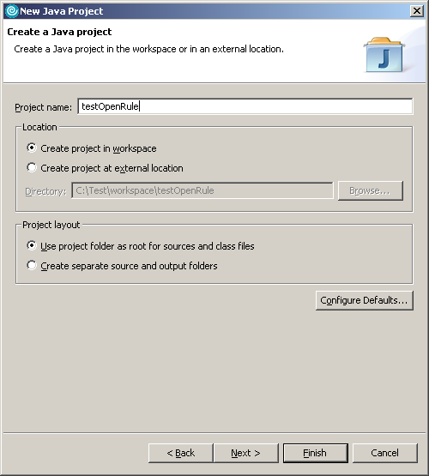

This would create the project - testOpenRules.

- Right-click the project.

Select Properties -> Java Build Path
-> Click on Libraries tab
-> Import the mentioned jar files

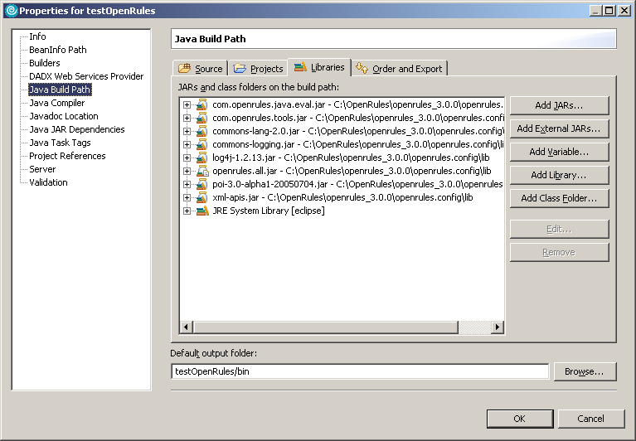

These jar files would be available as a part of OpenRules Framework.

- Extract the contents of testOpenRules.jar (this is made available with this document) file to a folder C:\testOpenRules

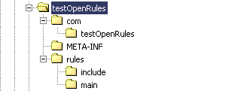

- Extract the contents of this folder into the testOpenRules project

Select File -> Import -> File System

Choose the appropriate folder and say Finish

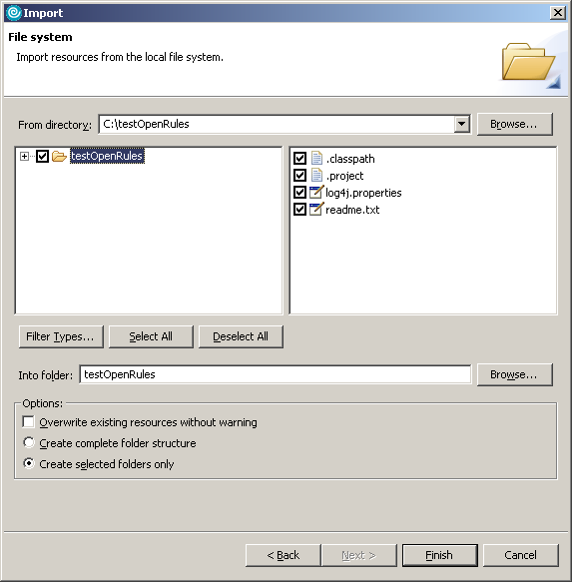

The exploded view of the project would be as shown

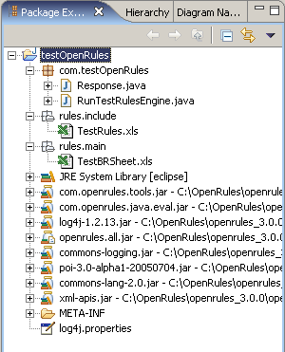

- Run the stand-alone Java program RunTestRulesEngine.java as shown below

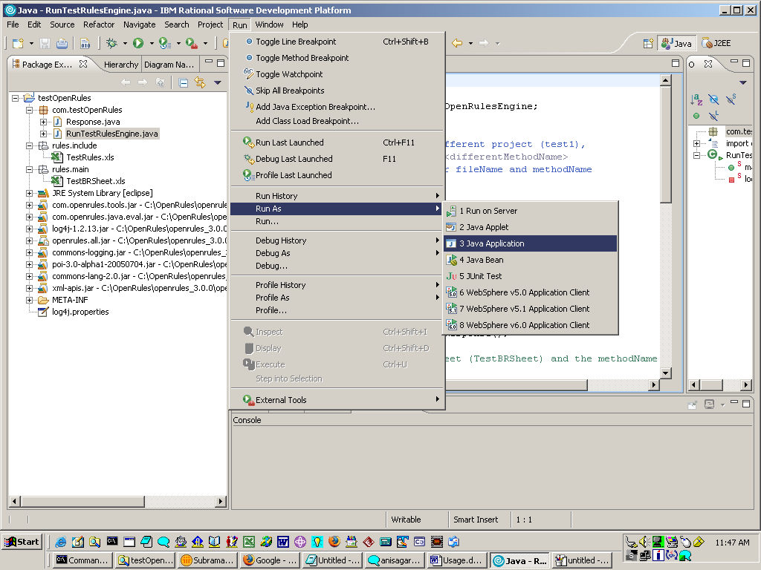

Code walk through

- For J2EE/Java application to invoke the OpenRules Engine, the following information would be necessary – fileName and methodName

String fileName = "file:rules/main/TestBRSheet.xls";
String methodName = "isExists";

Note: These can be passed as arguments as well. The rules folder can also be placed external to the project in a specified location. This externalization is especially useful when we integrate with existing web applications.

- Once the path of the business rule sheet is available the OpenRules engine is invoked passing the filename as the argument.

OpenRulesEngine engine = new OpenRulesEngine(fileName);

- Invoke the run method on the OpenRules Engine to execute the business rule or method.

Object obj = engine.run(methodName, objects);

Business Logic / Business Rule

The core to using OpenRules engine requires an understanding of how to go about using excel sheets for specifying and implementing the business logic. In OpenRules Engine, the business logic/decision making process to be implemented is captured using excel sheets.

In the example illustrated the stand-alone java program invokes a method isExists in the TestBRSheet.xls.

Method Boolean isExists(String a, Response r)
Where a is the string to be compared
And r is the Response object that contains a Map object.

The following snap shot shows the method used in the business rules sheet (sheet name - Launcher).

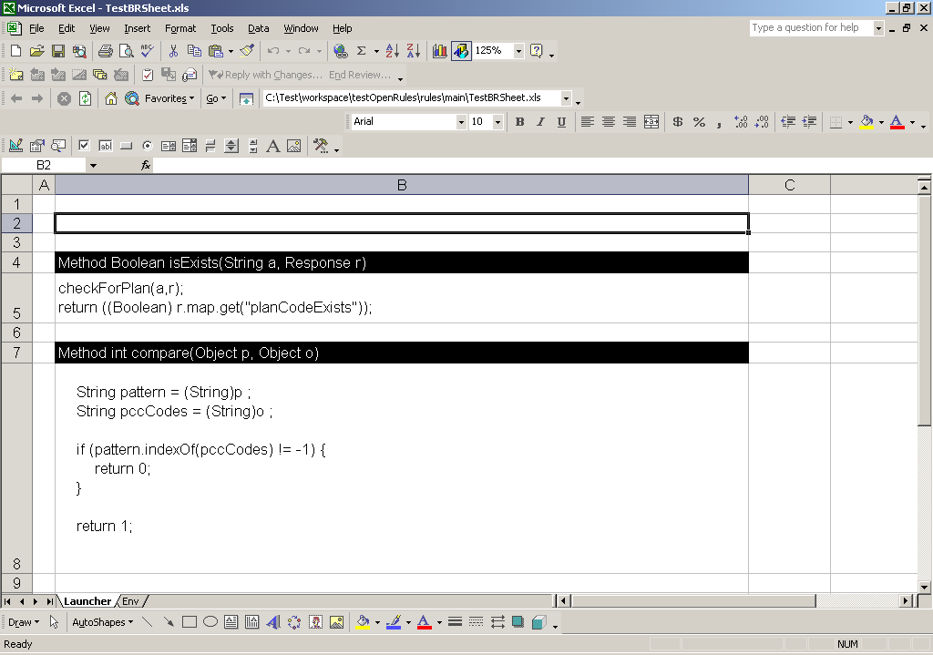

The set of classes accessible to the business rules sheet is mentioned through an “Env” sheet.

1) import .java The fully qualified names of the set of application specific Java classes that are available in the Business rules sheet. This would be the list of all classes in testOpenRules.jar that would invoke the OpenRules Engine.

2) import.static The OpenRules API methods that can be directly used in the business rules sheet – these are the equivalent to static imports in JDK 1.5.

3) include The list of business rules sheet that are accessed from TestBRSheet.xls.

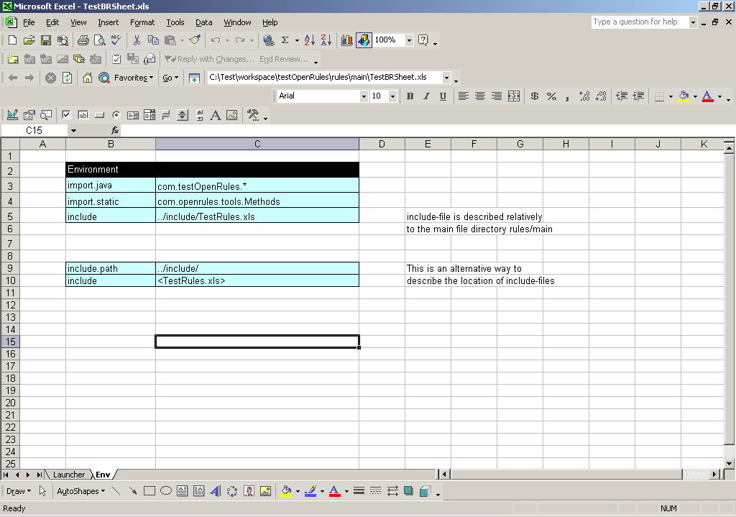

TestRules.xls

The TestRules.xls sheet follows the OpenRules Engine specification syntax that works on a set of arguments and for a given condition (C1) performs a corresponding Action (A1).

In the example below, the cell B5 contains the core logic in the form of a Java snippet that checks if the return value of compare method is 0 or not.

Java Snippet: (compare(a, planCodes) == 0)

Here planCodes is a locally declared String variable (cell B6) that takes one of the values mentioned in the cells that range from B8 to B12.

This in-turn invokes the compare method (shown in the previous sheet), that does the business logic processing (simplified here to a String comparison for easier understanding) and returns a suitable value.

Note: The rows 4 to 6 that are marked in green represent the processing part of the business rule/logic. This need not be made available to the business analyst. The inputs (planCodes) and the outcome are pre-determined with the processing part tucked away (hidden if necessary) from the business analyst.

For a complete understanding of the operations of the OpenRules Engine please refer OpenRules Engine site www.openrules.com.

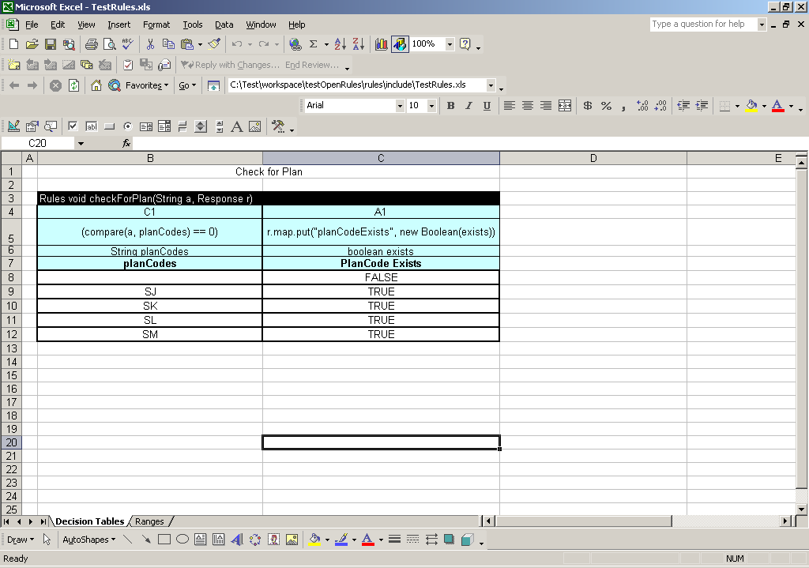

Console Output

The following would be the console output when RunTestRulesEngine.java is run.

Inside RunTestRulesEngine
Inside RunTestRulesEngine fileName : file:rules/main/TestBRSheet.xls methodName : isExists
INITIALIZE OPENRULES ENGINE for [file:rules/main/TestBRSheet.xls]+
Create DataSource from file:rules/main/TestBRSheet.xls
[file:rules/main/TestBRSheet.xls] has been resolved to [file:rules/main/TestBRSheet.xls]
LANG: com.openrules.lang.xls
IMPORT.JAVA=com.testOpenRules.*
IMPORT.STATIC=com.openrules.tools.Methods
INCLUDE=../include/TestRules.xls
Find ../include/TestRules.xls in file:rules/main/TestBRSheet.xls
Resolving data source. Parent [file:rules/main/TestBRSheet.xls]. Path [../include/TestRules.xls]
Create DataSource from file:rules/main/TestBRSheet.xls
Parent path file:rules/main/TestBRSheet.xls has been resolved to file:/C:/Test/workspace/testOpenRules/rules/main/TestBRSheet.xls
[../include/TestRules.xls] has been resolved to [file:/C:/Test/workspace/testOpenRules/rules/include/TestRules.xls]
Create DataSource from file:/C:/Test/workspace/testOpenRules/rules/include/TestRules.xls
LANG: openrules.java
Create DataSource from classpath:/com/openrules/java/openrules.system.xml
Create DataSource from classpath:/openrules.user.xml
Successfully processed configuration: URLDataSource:jar:file:/C:/OpenRules/openrules_3.0.0/openrules.config/lib/openrules.all.jar!/com/openrules/java/openrules.system.xml
LANG: file:rules/main/TestBRSheet.xls

=====================================================
OpenRulesEngine: file:rules/main/TestBRSheet.xls
=====================================================

checkForPlan
[TffTf]
Value from isExists method true

Integration of OpenRules Engine with Web Application

Having created a stand-alone application jar file (testOpenRules.jar) to invoke the OpenRules Engine, the integration with a web application isn’t too far away.

The following procedure needs to be adopted to integrate OpenRules with an existing web application. Here OpenRules is maintained as a separate project so that it can be easily plugged in.

- Create a separate project – java or a web project.

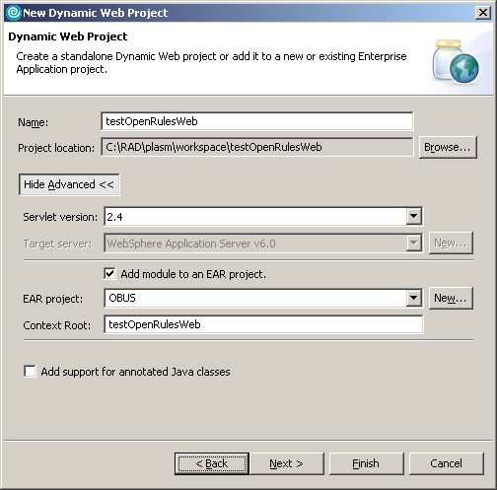

This project would be used by the existing web application to invoke methods/rules on the business rules sheet. It basically provides an interface for invoking the business rules and returns the result to the invoking class.

One of the suggested approaches is to place the rules file(s) in a separate location and appropriately modify the fileName attribute. This allows us to have the business rules stored outside of the .war or .ear file. The changes to the business rules in these excel sheets are reflected on the fly – requiring no re-building or re-deployment of the application.

- In the Java Build Path of the newly created project, import the OpenRules Framework jar files.

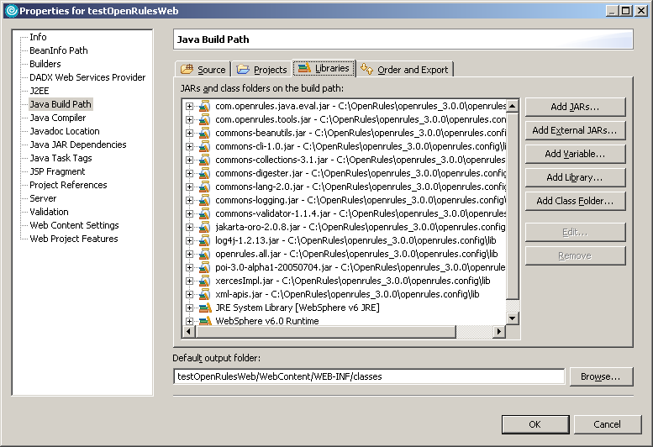

- Include the newly created project in the Java Build Path of the project that uses OpenRules functionality.

All that is required for integration of OpenRules Engine with existing web application is to have a suitable project (java or a web project) – and have this imported into RAD, making available the name of the class that invokes OpenRules Engine – here RunTestRulesEngine.java.

This accompanied by the set of jar files used by OpenRules Framework is all that is needed as a part of integration.

Conclusion

Change, being the only factor common across web applications, a tool to factor in this change and integrate easily with the existing application would be an immense value-add for applications.

The biggest advantage of using OpenRules Engine lies in its flexibility to change the business rules in the excel sheet at run time and have these reflected in the application – requiring no additional build, deployment or server startup. Add to that, the fact that it easily integrates with existing web applications also results in a smaller learning curve and easier adoption.

